
Certificate of Attendance
Rural Integrated Behavioral Health in Primary Care
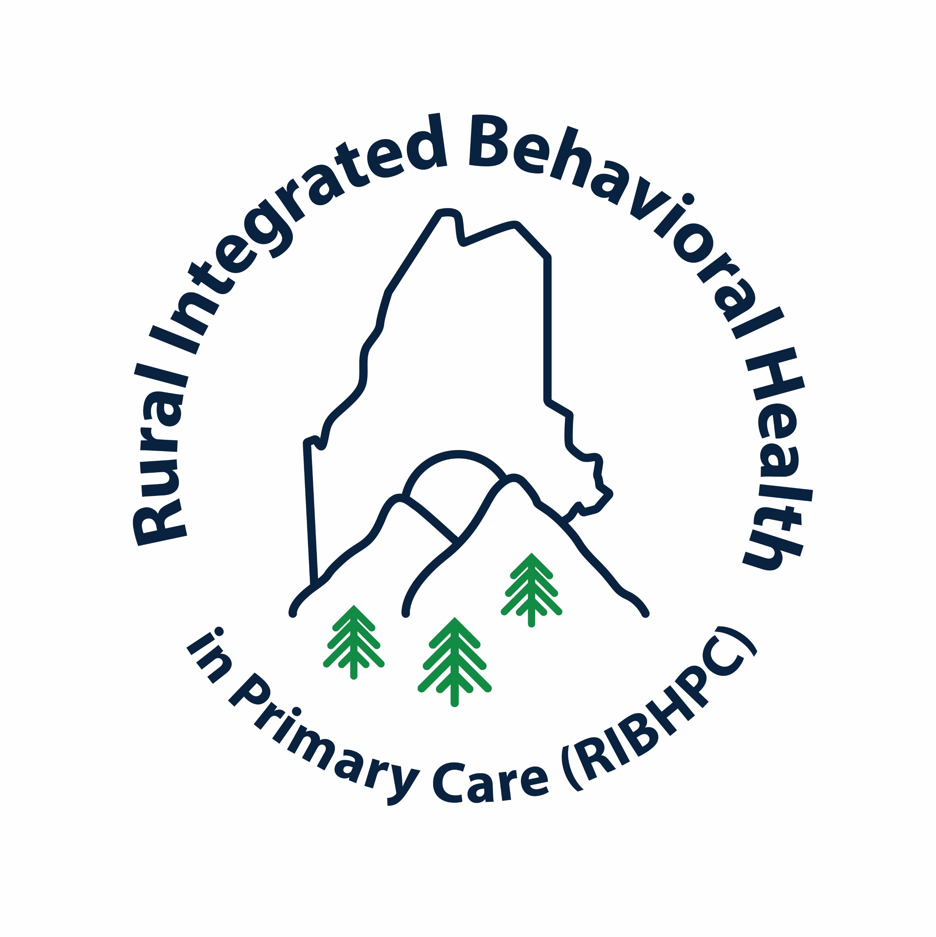
This is to certify that:

__________________________
ATTENDED
Practical Considerations for Telehealth: Best Practice Discussion

By
Dr. John Campbell, MD and Colleen Owens, LCPC

On
Friday, April 21, 2023, Live Webinar 12:00 – 1:00 PM

This educational program qualifies for 1.0 contact hours
____________________________________
Jennifer Scott, LCSW
Rural Integrated Behavioral Health in Primary
Care Project Coordinator
University of Maine, Orono, 04469
________________________________
Dr. Jeff Hecker
Professor of Psychology
University of Maine, Orono, 04469

